How to write sensory Bible stories

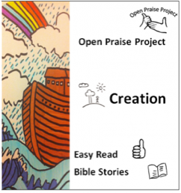 | Places you can get pre-made stories:  https://openpraiseproject.com/downloads/  http://www.twinkl.co.uk/resources/bible-stories/2 (subscription needed –- or speak to a teacher friend)  https://inclusiveteach.com/2025/07/27/bible-sensory-story-moses-and-the-burning-bush/
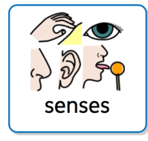  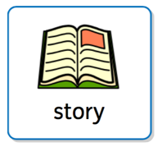 | What is a sensory story?  - A story broken down into approx. 5-10 key sentences.  - One key sentence developed as the main teaching point. (What is this teaching us)  - A sensory experience chosen for each key sentence.  - The story delivered with time for all to participate in the sensory experiences.
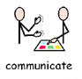 | What are some benefits of sensory stories?  - Pace is slower  - Effective communication  - Engagement  - Awe and Wonder  - Spiritual truths communicated simply Inclusive  - Encourages reflection
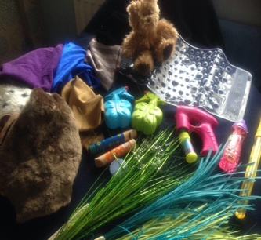 | Sensory experiences can include:  - Touch, taste, sound, smell, sight  - Movement and whole body experiences.  - Household items, bought items, toys, mixtures you’ve made.  - Songs, Lego, repetitive actions, large equipment  - repetitive phrases, actions to key words.
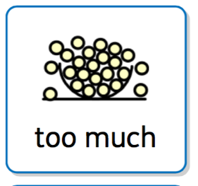 | You should take into account:  - Sensory sensitivities,  - Safety (eg. mouthing/PICA),  - Respecting ‘no thanks’,  - Time to process the sensory experience and the words (or symbols) to go with it.  - Keep it simple and don’t overwhelm with too much sensory stimulation at once.
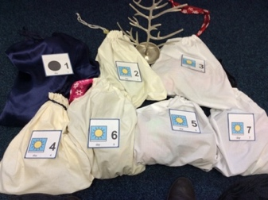 | Sensory Ideas:  - Pinterest  - Instagram, Tik Tok  - www.flamecreativekids.blogspot.co.uk  - https://www.almaautism.uk  - Messy Church – but remember, less is best!
Story telling and sensory links:

“Play through the Bible” by Alice Buckley
www.easyenglish.info
www.freebibleimages.com
Symbols: www.widgit.com
http://jo.element42.org/sensory-stories

