Teaching, Equipping and Flourishing – Teens with Additional Needs growing into the Body of Christ.
By Lynn McCann www.includedbygrace.wordpress.com

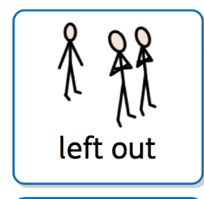 | A lot of advice is concentrated on children with additional needs or occasionally for supporting adults. There isn’t much out there for recognising the unique needs of teenagers with AN and their transition into the adult world.  As churches and youth workers what are these challenges?  Teenagers with AN are facing the same challenges of puberty, growing up, leaving school and finding their place in the world as all teenagers are. But they have significantly less opportunities than most young people.
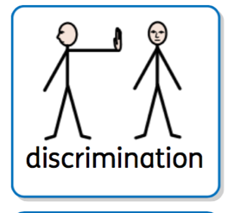 | Social inclusion, having opportunities to make friends and be part of a peer group is what many want but don’t have.  - Less chance of gaining good qualifications  - Less chance of getting a job or apprenticeship  - Less chance of being able to live independently  - More chance of being the victim of a hate crime  - Less likely to have a supportive friendship circle  - Most likely to need support of some kind throughout their lives  - Less opportunities to be able to use their gifts and talents  - As able as anyone else to be part of God’s family!
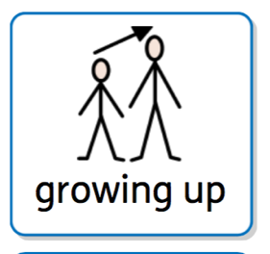 | Challenge 1 – Growing Up  - Talk to them & get to know their strengths and ambitions - talk to parents / support the family.  - Understand how they will grow and change physically.  - Transition from Youth groups into young adult. Maybe developing a leader/helper role.  - Teaching about teen issues – drink, drugs, risks, sex, exploitation, respect, consent, Baptism, marriage, faith, suffereing… etc. Communicating in an appropriate way for them.  - Develop a habit of Bible learning and prayer.
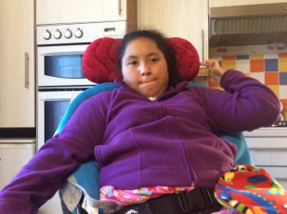 | Chelsea’s main points:  - Talk to the person themselves.  - Ask them what they want, or what their problems are.  - Help them be friends with others and use their talents in the church.  Chelsea was baptised last year and also organised a whole church talent show to raise money for a charity when one of her friends passed away. She’s a talented actress and singer too.
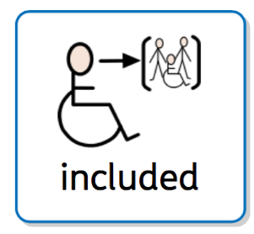 | Challenge 2 – Social Inclusion  - Ask the young person what they want.  - Keeping them with their peers rather than younger children?  - Encouraging and enabling social invitations.  - Encouraging interdependence between all the kids the same age (group projects for eg.)  - Supporting a ‘buddy’ group for those with learning disabilities or severe needs.
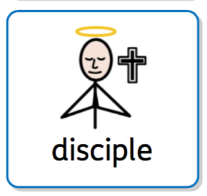 | Challenge 3 – Spiritual Development  - Find ways of accessing the whole Bible (eg. Lego Bible, Graphic Bible, Interactive Websites, specialist resources from Prospects etc.)  - Make a plan with the young person and parents to move through a set of topics in a year or set time.  - Make or find resources  - Teach them how to pray.  - Involve them in contributing to church life.  - Make church life accessible.  - Develop true friendships with all ages.  - Have high expectations of their ability to access God’s word and the Holy Spirit’s ability to teach them!
John’s main points:
John has been to church since he was a baby. His first word was “Halelujah!”
Although his church groups were well led and used lots of inclusive practice, John’s mum says he never was invited to any other child’s parties.
John has a real gift for computing and operates the SongPro system at his church.
John likes the way we use the Easy English Bible which he can understand better.
He likes being able to pass on his computer knowledge and train others to use the program.
John would still like friends he could meet outside church, and would love to meet a nice woman he could marry.

